MRMv2 Design Workbench Documentation

MRMv2 Design Workbench Documentation 1
Introduction 1
The tools 1
Implementing Features within MRMv2 Design Workbench 3
Feature 1: Copy 4
Feature 2: Classify 8
Features 3-6: Filtering and Sorting 9
Feature 7-16: Add 11
Feature 17-20: Delete 13
Feature 21-24: Change 14
Feature 25: List 15
Feature 27: Approve 15
Feature 28,29: Comment 15
Features 30-33: Output 16
Feature 34-36: Compare 18
Feature 37: List 19
Feature 38: Customize Collaboration Site 19
Feature 39: Create 20
Feature 40: Security 20

Introduction
The MRMv2 Design Workbench is the tooling platform used to work with MRMv2 meta model, reference model and instance models. This document will describe how to implement the features described in the “Business Use Cases, Tasks, Operations, Features and Meta Model Specifications” (v.19) document using the MRMv2 Design workbench. This document will not replace the user documentation for any of the tools but provide specific information related to implementing the features in the MRMv2 Design Workbench.

The tools
The MRMv2 Design Workbench consists of multiple tools from IBM including Lotus Quickr, Rational RequisitePro (ReqPro), Rational Requirements Componser (RRC), Rational Publishing Engine (RPE) and Rational Software Modeler (RSM). The tools, shown in Figure 1, are used by three roles within a jurisdiction, a Business User, a Business Analyst, and a Meta Modeler.
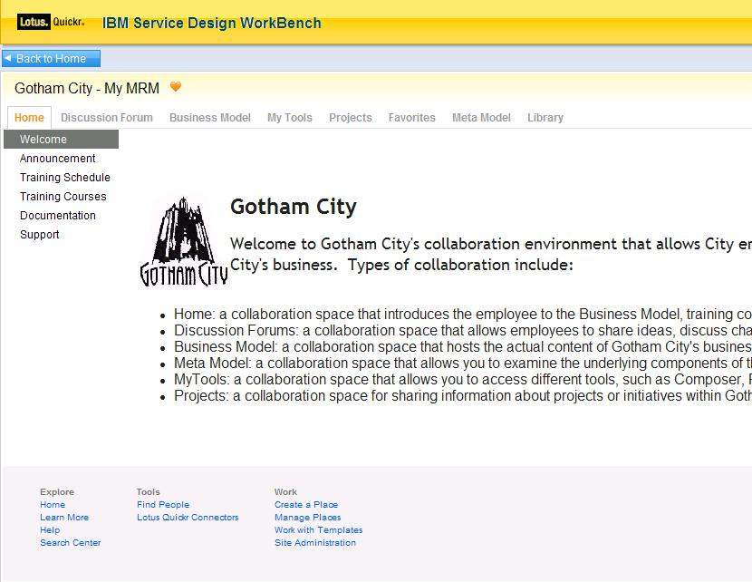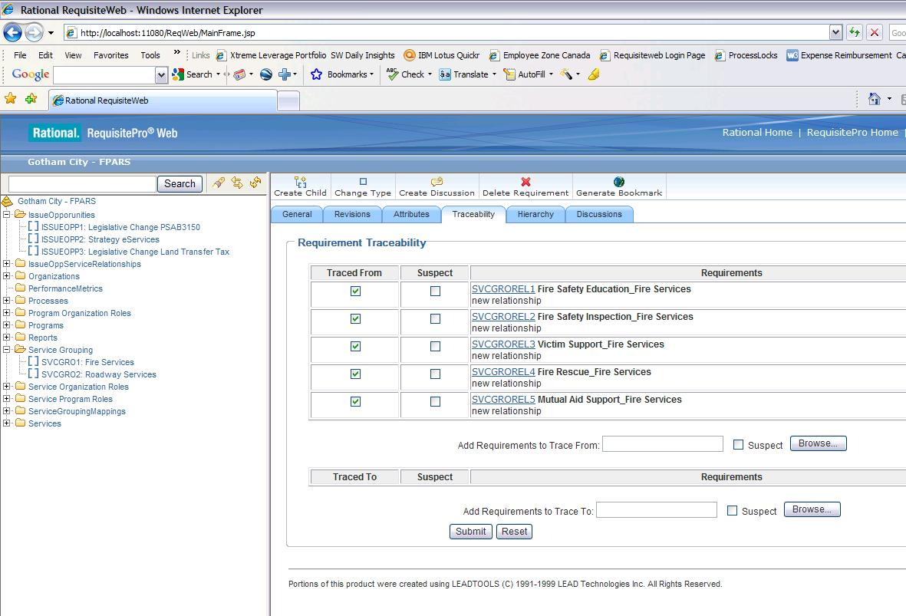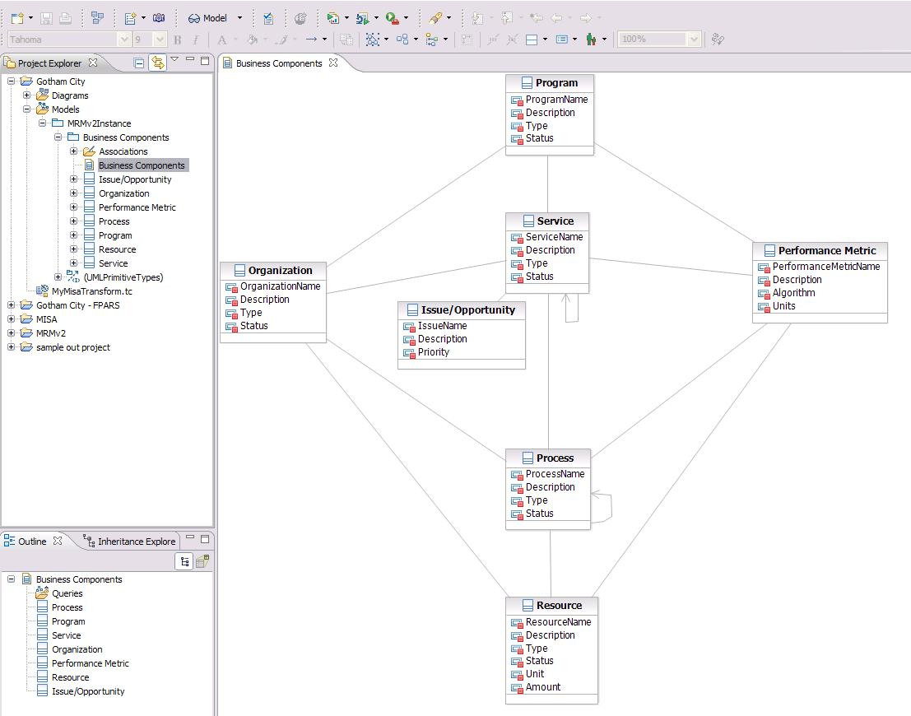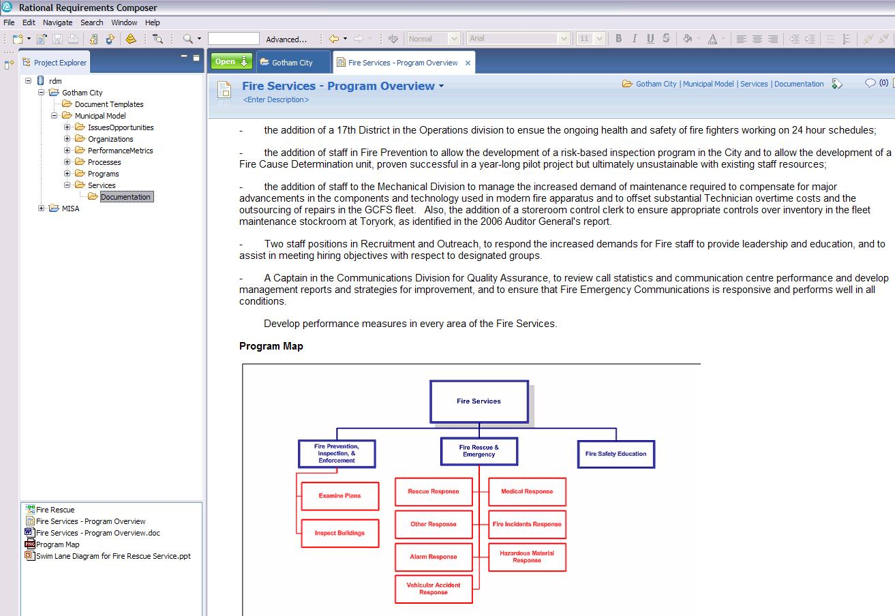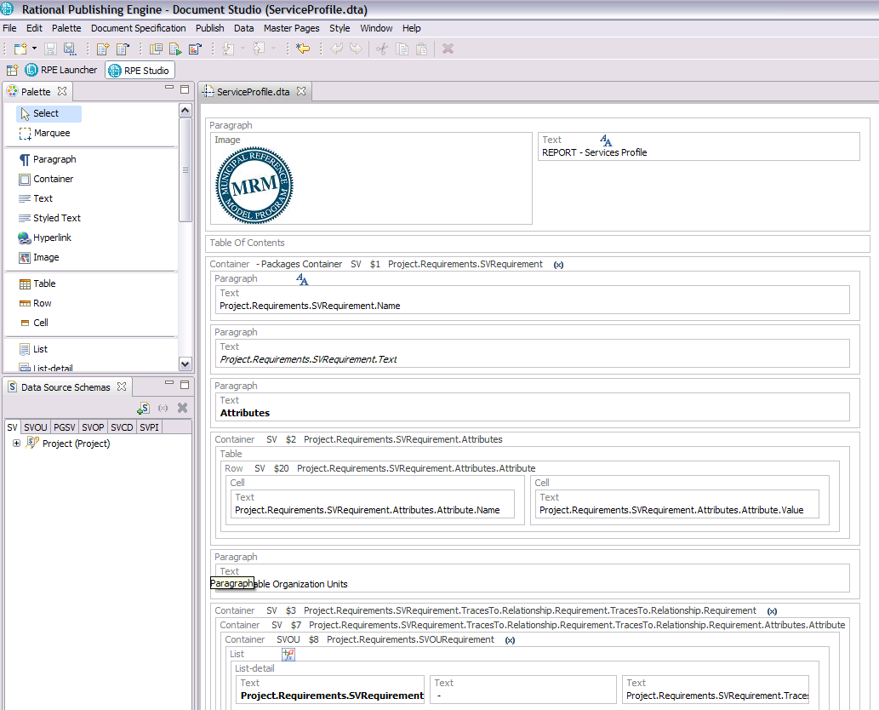
Lotus Quickr
Rational RequisitePro
(ReqPro)
Rational Software
Modeler (RSM)
Rational Requirements
Composer (RRC)
Rational Publishing
Engine (RPE)
Business
User
Interface
Business
Analyst
Interface
Meta (Data)
Modeler
Interface

Figure 1. MRMv2 Tools

Lotus Quickr is used by all roles but primarily the Business User to review their project artifacts and to collaborate with others. Accessed through the web, Lotus Quickr provides a simple web interface to MRM content both within a jurisdiction and across jurisdictions.
The Business Analyst has three tools for manipulating MRM content. Rational RequisitePro is used by the Business Analyst to instantiate MRM business components and establish relationships among them. RequisitePro has both a thick client user interface as well as a web user interface know as RequisiteWeb. Rational Requirements Composer is used by the Business Analyst to elaborate on MRM content with rich text documents, Business Process Models, Use Case diagrams and Storyboards. The Rational Publishing Engine is used to produce documentation and reports based on the data being captured in the other tools.
The Meta Modeler is a specialized role for manipulating the underlying MRM meta model within Rational Software Modeler. Figure 2 shows a summary of the roles and functionality.

Lotus Quickr
Rational
RequisitePro
Rational Software Modeler
Rational
Requirements
Composer
Business User
Business Analyst
Meta Modeler
Review business component content published from ReqPro, RRC, RSM
Collaborate – forums, wikis

ReqPro
Create & manage business components
Query business components
Compare business components
Import/Export business component matrices
RRC
Elaborate on business components with documents, BPM diagrams, UC diagrams
RPE
Produce reports

Create and extend MRM meta-model
Compare meta models (versions of one municipality or across municipalities)

Rational
Publishing
Engine
Figure 2. Roles and tooling functionality

Along with the products from IBM there are a number of extensions that were created to allow further integration between products and increased functionality. These extensions are described in other specifications, namely - “MRMv2 RSM Transformations” and “MRMv2 RequisitePro Extension”. The user documentation for each tool can be found at the following URLs:

ReqPro 7.1: http://publib.boulder.ibm.com/infocenter/reqpro/v7r1m0/index.jsp
RRC 2.0: http://publib.boulder.ibm.com/infocenter/rpcmpose/v2r0/index.jsp
RPE 1.1: http://publib.boulder.ibm.com/infocenter/rsdp/v1r0m0/index.jsp?topic=/com.ibm.help.download.tpe.doc/topics/publishingengine_version1_1.html
RSM 7.5: http://publib.boulder.ibm.com/infocenter/rsmhelp/v7r5m0/index.jsp
Quickr 8.1: http://publib.boulder.ibm.com/infocenter/lqkrhelp/v8r0/index.jsp

Implementing Features within MRMv2 Design Workbench

There are 40 features described in the Business Use Cases document. Each feature will be described with an explanation of how to implement the feature in the related tools.

Feature 1: Copy

Operation | Feature No. |  | Feature Description |  | SDW Tool
Copy |  |  |  | - Create a copy of a model |  | - RRC  - RSM  - ReqPro

This feature deals with creating a copy of a model and is accomplished with RRC, RSM and ReqPro. Let’s describe how each tool supports the copy of a model. First, we need to elaborate on what we mean by model. There are two aspects to a jurisdictions model, its meta model and instance model (instance model is created from initial MISA reference Model). Therefore, when copying a model for the purpose of starting a new project in a jurisdiction, or creating the first model for a jurisdiction after joining MISA, we need to show how we copy both the meta model and instance model for a jurisdiction. The meta model work occurs in RSM while the instance model work occurs in ReqPro and RRC.
We’ll start off by describing how to create a copy of the meta model in RSM. The MRMv2 meta model is an emx file - MRMv2MetaModel.emx. To view this model in RSM we’ll need to first create a project in RSM that will contain the model. To create a project in RSM, simply go to File -> New -> Model Project.

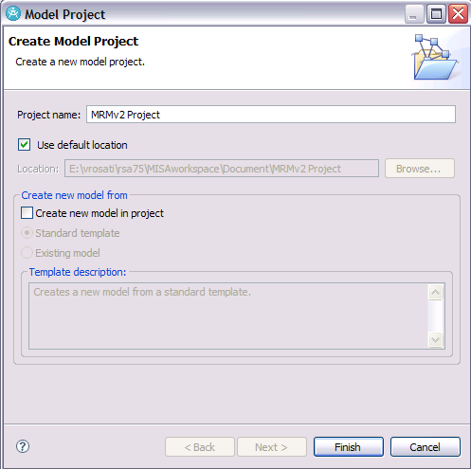

Figure 3. Model Project in RSM

As shown in Figure 3, give the project a name and deselect the “Create new model in project”. Click Finish. Once the project is created, right click on it and select Import….
For import source, select General and then File System. Browse to the MRM emx file on your computer and then select Finish. Refer to the RSM documentation if you have any trouble importing.
Once the MRM meta model is loaded into your project, we’ll need to create a copy of it. You can either create a copy at the file system level in windows (ie. in windows explorer create a copy of the MRMv2MetaModel.emx and call it MyCity.emx) and then import the copy into a separate project or you can create the copy in RSM. To do so in RSM, open the “Navigator” view. Go to Window->Show View as shown in Figure 4.
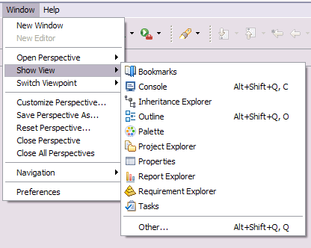
Figure 4. Show View

Select Navigator if it is present or Other… if the Navigator view is not present. If you chose Other… then the Navigator view can be found under General. Once the navigator view is open you can right click on the emx file and select copy as shown in Figure 5.

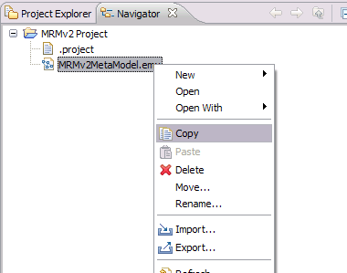
Figure 5. Create a Copy in Navigator view

Once the copy is made, you can paste the emx file into any modeling project and make changes without affecting the original. You can also compare the copies as we will discuss later.

In RequisitePro, copying a model means to copy an instance model and therefore the entire RequisitePro project. There is one RequisitePro project for each instance model. There are two ways to create a copy of a RequisitePro Project. One way is to create a project template and the other way is to create a project from a baseline. For MISA, it is recommended that a project template is created based on the reference model and is used to create each jurisdictions initial project in RequisitePro. Project templates provide a way to copy structure and data in a consistant manner. To create a project template refer to “Creating a Project Template” (http://publib.boulder.ibm.com/infocenter/reqpro/v7r1m0/index.jsp?topic=/com.ibm.reqpro.help/administering/projects/creating_modifying/t_creating_proj_template.html) in the product documentation. Make sure the project data option is used or the template will only copy project structure.

Once a jurisdiction is working within their RequisitePro project(s), they may decide to spawn additional projects from a stable version of their initial project. To do so, it is recommended that a baseline is created and then the new project is created from the baseline. To create a baseline, refer to “Creating Rational RequisitePro Baseline” (http://publib.boulder.ibm.com/infocenter/reqpro/v7r1m0/index.jsp?topic=/com.ibm.reqpro.help/administering/projects/baselines/t_creating_reqpro_baselines.html) in the product documentation. To create a RequistePro project from a baseline refer to “Creating a project from a Rational RequisitePro project baseling” (http://publib.boulder.ibm.com/infocenter/reqpro/v7r1m0/index.jsp?topic=/com.ibm.reqpro.help/administering/projects/baselines/t_creating_proj_from_proj_baseline.html ).

In Rational Requirements Composer (RRC), a project also represents an instance model of MRM. Each RequisitePro project is associated and linked to an RRC project. When working with RRC and RequisitePro, the model recommended for MISA to use is described in Scenario 2 of the user documentation in RRC : (http://publib.boulder.ibm.com/infocenter/rpcmpose/v2r0/topic/com.ibm.rational.rrc.help.doc/topics/c_integ_scenario_2.html), where requirements (business component and relationship instances) are created in RequisitePro and then further elaborated on in RRC. For information on how to link and import RequisitePro data into RRC see “Importing requirements from RequisitePro” (http://publib.boulder.ibm.com/infocenter/rpcmpose/v2r0/index.jsp?topic=/com.ibm.rational.rrc.help.doc/topics/t_import_reqs.html).
For MISA, a copy of an RRC project will be required as new jurisdictions join the program. Also, within a jurisdictions a copy may be required when working on new projects. There is no project copy in RRC so the approach will have to rely on the download/upload features of RRC. This can be a little tedious but overall it will accomplish what is required. First off, no requirements from RequisitePro should be downloaded and uploaded to a new project. Instead, the new project in RRC should import the content from the newly created RequisitePro project. So, it is recommended that the directory structure of an empty RRC project be downloaded and used to seed all newly created RRC projects. The content within the RRC project will then be developed new, or imported on a asset by asset bases. All RequisitePro data required to be imported should be done so as well by connecting the newly created RRC project to the corresponding ReqPro project.

Feature 2: Classify
Operation | Feature No. | Feature Description | SDW Tool
Classify |  | - Record a value in a temporary attribute in one or a group of [bc] / [r] instances to classify, sort, etc. | - ReqPro

In RequisiteWeb, an attribute can be added to any business component or relationship for the purposes of classifying. To add an attribute in RequisiteWeb, launch the administrative tool as shown in Figure 6 which is in the top right hand corner of the UI.
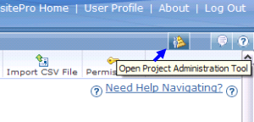
Figure 6. Launch Admin tool in RequisiteWeb

Next, select Requirement Types and Attributes tab as shown in Figure 7.

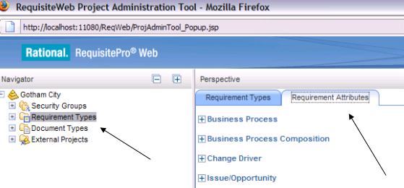
Figure 7. Attributes management in RequisiteWeb

Expand the Business component if you wish to see the current attributes. To add an additional attribute select the button in the right hand corner as shown in Figure 8.

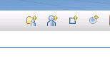
Figure 8. Add Attribute button

Follow the instructions on the form to save the new attribute. Once the attribute is created, it can be sorted on or queried on when creating views. For more information on views refer to the user documentation for RequisitePro.

Features 3-6: Filtering and Sorting
Operation | Feature No. |  |  | Feature Description |  | SDW Tool
Filter |  |  | - Filter a list of [bc] and [r] instances based on values or value ranges of one or more [bc] and [r] attributes and/or joined [bc] instances |  | - ReqPro
 |  |  | - Make the filter of [bc] and [r] instances reflexive – filter the list, then re-filter the resulting list with different parameters and so on. |  | - ReqPro
Sort |  |  | - Sort a list of [bc] instances based on values of one or more [bc] attributes |  | - ReqPro
 |  |  | - Sort a list of [bc] instances based on values from the attributes of the [r] and/or the joined [bc] instances |  | - ReqPro

Filtering and sorting of Business Components and Relationship instances in RequisitePro occurs within views. A view in RequisitePro allows users to create listings of instances showing attribute values. These listings can be filtered and sorted. For information on creating and managing views in RequisiteWeb refer to “Working with Views” (http://publib.boulder.ibm.com/infocenter/reqpro/v7r1m0/topic/com.ibm.reqpro.reqweb.help/proccreatemodview_help.html).
Views can include queries that span multiple business components if they are traced together through the Trace To or Trace From relationship. The following example will show how to create a view containing Programs that are related to a particular Service. This will require a view that contains a join, as well as a filter because we only want to analyze one Service. Before we begin, we must understand how Programs and Services are related. By analyzing the Entity Codes (displayed after logging into RequisiteWeb) we find there is an entity for related Programs and Services called PGSV – Program Services. This is a relationship entity from the MRM meta model. When we create a relationship between a Program and Service (in RequisitePro extension – Matrix builder), a Program Service PGSV entity is created in RequisitePro. From the acronym PGSV, we know that Programs are traced to Services. This is so because PG comes before SV in the acronym and the matrix builder builds relationships based on the order of codes. So, because PG is before SV then it builds a trace to relationship from the Program to Service. Therefore, from the Service there would be a trace from relationship to the Program.

This example uses random test data and therefore may not make sense in terms of which Programs and Services are related. Again, the view we are creating will return all Programs that are related to a particular Service. In our example we will use the “Taxi Vehicle / Driver Licensing” Service. To verify which Programs are related to this Service check the Traceability Tab for your Service. Figure 7 shows this for the Service we are interested in. The resulting traceability tab shows us the PGSV’s that are traced from our Service and not necessarily the actual Programs or PG’s. But it is evident from the Name of the PGSV’s the program that’s related. Nonetheless, let’s build a view.
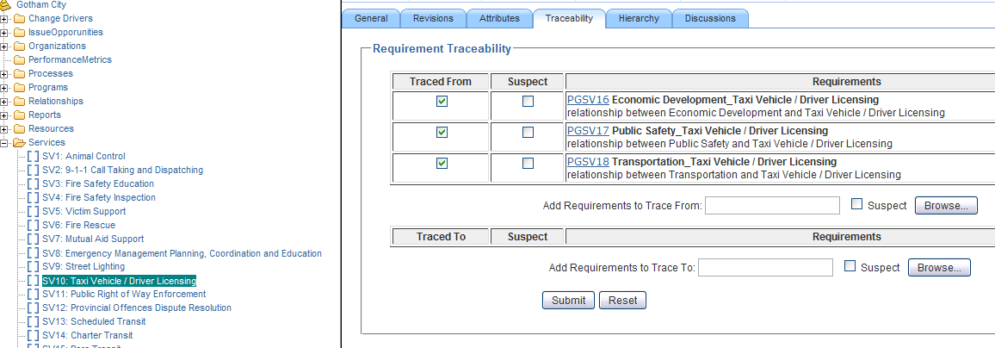
Figure 7. PGSV’s related to a Service

The following steps are used to create the view:
- In RequisiteWeb, select the root of the project and then the Create View button.
- Select the Attribute Matrix radio button, PG: Program as the Row Requirement Type and then click the Filter button.
- A number of View properties and Display options appear. In order to filter out Programs that map to Service “Taxi Vehicle / Driver Licensing”, we’ll need to filter on the Trace To attribute of the Programs. As shown in Figure 8, select SV: Service as the Requirement Types, select Trace-to as the Operator, Any as the Depth and then click filter…
(The Any Depth is required because SV’s are not directly traced to PG’s. They are indirectly traced through PGSV’s)

Figure 8: Filtering on Trace To attribute

- After clicking the filter button, a screen showing SV attributes is shown (Figure 9). For the Requirement Name attribute, select Includes and for the value enter “Taxi”. Selecting the View button will show the result of the view.

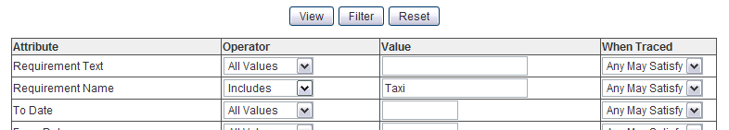
Figure 9. Setting SV criteria

- The result of the view is displayed showing all Programs listed that are related to the SV Service “Taxi Vehicle / Driver Licensing”

Note that Views can be saved within your project. You can further filter or sort any view by clicking on the “Filter, Sort, or Save View” button when viewing the results of a view.

Feature 7-16: Add
Operation | Feature No. |  |  | Feature Description |  | SDW Tool
Add |  |  | - Add [bc] and/or [r] definition to meta model. |  | - RSM  - ReqPro
 |  |  | - Add a single [bc] or [r] instance, including one or more attribute values |  | - ReqPro  - RRC
 |  |  | - Generate a [bc] and [r] instance serial no. programmatically (note: there is no user intervention required) |  | - ReqPro
 |  |  | - Validate/enforce model semantics on [bc] and [r] instances |  | * Manual operation
 |  |  | - Add [bc] and [r] instances in bulk – import and validate multiple [bc] and [r] instances and attributes from other sources |  | - ReqPro  - RRC
 |  |  | - Add template for reporting [bc] instance(s) (when describing [bc] in rich text documents) |  | - Publisher
 |  |  | - Allow multiple types of relationships between [bc]s |  | - ReqPro
 |  |  | - Allow reflexive relationships on a [bc] |  | - ReqPro
 |  |  | - Add diagram (eg. Business Flow, SIAM) |  | - RRC
 |  |  | - Import external documents into collaboration site |  | - Quickr

- Feature 7 – To add a Business Component or Relationship to the meta model requires changes to the meta model in RSM and the Schema in RequisitePro. To change the meta model in RSM simply open the model and make the required changes. All classes, associations, and attributes can be modified through the RSM UI. For specifics regarding managing model content refer to the RSM user guide. For RequisitePro, the schema change can either occur through the administrative aspect of RequisiteWeb (Figure 6) or the RSM Transformation can be run to update RequisitePro (Note: The RSM transform only supports additions made to metamodel). See MRMv2 RSM Transformations document.
- Feature 8 – Adding a Business Component instance in RequisitePro is known as adding a new Requirement. See “Creating Requirements” (http://publib.boulder.ibm.com/infocenter/reqpro/v7r1m0/topic/com.ibm.reqpro.reqweb.help/proccreatereq.html). For RRC, the requirement from RequisitePro can be imported into RRC and then any number of assets can be created in RRC to elaborate on the requirement. See “Creating artifacts to support Requirements” (http://publib.boulder.ibm.com/infocenter/rpcmpose/v2r0/topic/com.ibm.rational.rrc.help.doc/topics/t_create_artifacts.html)
- Feature 9 – In RequisitePro, after a Business Component instance is created it will be assigned a unique id. Unique ID is a system attribute assigned by default.
- Feature 11 – In RequisitePro, a number of Business Component instances can be uploaded in bulk using CSV files. See “Importing requirements in a CSV file” (http://publib.boulder.ibm.com/infocenter/reqpro/v7r1m0/topic/com.ibm.reqpro.reqweb.help/t_import_csv.html). When importing a CSV, it is recommended that you first perform an export to CSV to see what the required format is. Make sure to export all relevant attributes. Once you have the export and structure for the CSV, populate it and perform an import. In RRC, once the instances are loaded into RequisitePro they can be imported into RRC. Also, RRC allows multiple files or assets to be uploaded to the RRC server at once. See “Uploading files to a repository” (http://publib.boulder.ibm.com/infocenter/rpcmpose/v2r0/index.jsp?topic=/com.ibm.rational.rrc.help.doc/topics/t_upload.html)
- Feature 12 – See MRMv2 RPE Reports document.
- Feature 13, 14 – See the MRMv2 RequisitePro Extension document for how to build relationships between business components. Both reflexive and multiple relationship types can exist between business components.
- Feature 15 – RRC supports Business Process Modeling Notation and use case diagrams. Use one of these paradigms to construct SIAM diagrams.
- Feature 16 – A Business Analyst is required to push content from RPE, ReqPro and RRC to Quickr so that Business Users can review and collaborate on the data. To upload content to Quickr, a BA will use the Lotus Quickr Windows Explorer Connector. Once this connector is installed on a BA’s workstation, they will be able to manage documents on their quickr place. See “Working with documents from your places list” (http://publib.boulder.ibm.com/infocenter/lqkrhelp/v8r0/topic/com.ibm.lotus.quickr.connectors.doc/libraries/qkcn_usr_lib_docs_t.html)

Feature 17-20: Delete

Operation | Feature No. |  | Feature Description |  | SDW Tool
Delete (actually implemented as Deprecate) |  |  |  | - Delete MRM core meta model and municipal model extension definitions / schema (delete model [bc] definitions and delete diagrams graphically depicting [bc] and [r] graphically) |  | - RSM  - ReqPro
 |  |  |  | - Delete single or multiple [bc] instances, selected by sorting and filtering operations |  | - ReqPro  - RRC
 |  |  |  | - Delete [r] associated with deleted [bc] |  | - ReqPro (release1 utility?)
 |  |  |  | - Delete business process flow diagrams |  | - RRC

Delete capability is available in all tools, refer to the respective documentation. There are some things to consider with regards to delete. In RequisitePro for instance, it is recommended that instead of deleting Business Components and Relationships, that the “Deprecated” attribute on the instance is set to true. The reason for this in RequisitePro is that we don’t want to loose the complete revision history of an instance when it is deleted. Therefore, by setting the Deprecated attribute to true, it will logically delete the instance instead of physically deleting it. In order for this logical delete to work, all views created RequisitePro, and all reports generated by RPE need to filter out Deprecated records. The matrix builder RequisitePro extension tool filters out Deprecated records.

Feature 21-24: Change
Operation | Feature No. |  |  | Feature Description |  | SDW Tool
Change |  |  | - Change MRM core meta model and municipal model extension definitions/schema (change model [bc] definitions and change diagrams graphically depicting [bc] and [r] graphically |  | - RSM  - ReqPro
 |  |  | - Change a single [bc] and [r] instance |  | - ReqPro  - RRC
 |  |  | - Make changes to multiple selected [bc] and [r] instances (bulk change via import) |  | - ReqPro
 |  |  | - Change diagrams |  | - RRC

Within RSM, changing a class name, attribute name or relationships between classes is very simple to do. Simply open the model and change items directly in the class diagram, or right click on the UML entity within the Package Explorer view and either use Add->UML, or rename. Also, the Properties view in the Modeling perspective is a great way to modify UML content.
Within RequisiteWeb, simply selecting any Business Component, Relationship, or saved View will display a web page of details all of which are modifiable. To do bulk changes in RequisiteWeb there are a few options. One is to modify attribute values of multiple instances at once. For instance, if we wanted to set the value of an attribute on multiple Service instances at the same time we could do so by first executing an attribute view where the attributes of the Services are displayed. Then, by highlighting the cells of the attribute (have ctrl key pressed as you highlight cells) we wish to change and right clicking on them, we will be presented with the option to “set value” as shown in Figure 9.
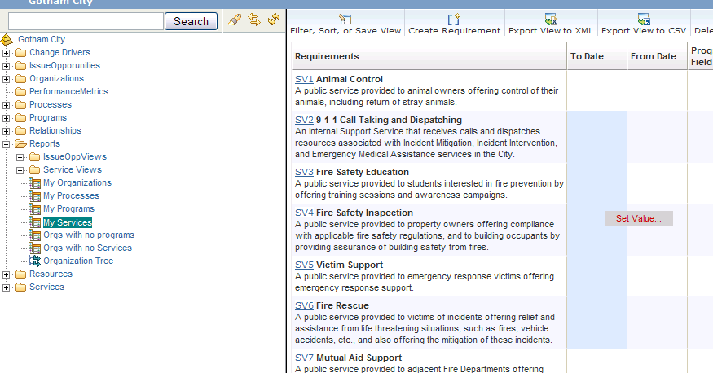
Figure 9. Multi-Value set on attributes
Another option in RequisiteWeb is to use the CSV import. See “Importing requirements in a CSV file” (http://publib.boulder.ibm.com/infocenter/reqpro/v7r1m0/topic/com.ibm.reqpro.reqweb.help/t_import_csv.html)

In RRC, any asset created can be modified through the UI. See product documentation for more details.

Feature 25: List

Operation | Feature No. |  |  | Feature Description |  | SDW Tool
List |  |  | - List [bc] and [r] instances with selected attributes |  | - ReqPro

Listing of Business component and Relationship instances are accomplished through creating views within RequisiteWeb. See “Working with Views” (http://publib.boulder.ibm.com/infocenter/reqpro/v7r1m0/topic/com.ibm.reqpro.reqweb.help/proccreatemodview_help.html).

Feature 27: Approve

Operation | Feature No. |  |  | Feature Description |  | SDW Tool
Approve |  | 27 | - Mark selected [bc] or [r] instances as approved |  | - ReqPro  - RRC

Approving elements within all tools requires a governance plan and strategy. From a tooling perspective there are mechanisms to assist with approval. In both ReqPro and RRC a working attribute (not required in meta model) can be added to the entities to reflect the current working state (ie. Draft, Implemented, Approved…).

Feature 28,29: Comment
Operation | Feature No. |  |  | Feature Description |  | SDW Tool
Comment |  | 28 | - Insert comments about selected [bc] and [r] instances |  | - ReqPro  - RRC
 |  | 29 | - Support discussion forums |  | - Quickr
Both RequisitePro and RRC support discussions allowing Business Analysts to have in context chats regarding any Business Component. For RequisitePro see “Discussions” (http://publib.boulder.ibm.com/infocenter/reqpro/v7r1m0/topic/com.ibm.reqpro.reqweb.help/discussions_help.html). For RRC see “Commenting on artifacts” (http://publib.boulder.ibm.com/infocenter/rpcmpose/v2r0/topic/com.ibm.rational.rrc.help.doc/topics/t_use_comments.html).

Features 30-33: Output

Operation | Feature No. |  |  | Feature Description |  | SDW Tool
Output |  | 30 | - Print/publish selected list of [bc] & [r] instances with custom formatting (design doc). Note this is exporting for review purposes. |  | - Publisher (from ReqPro or RRC)  - ReqPro
 |  | 31 | - Export selected list of [bc] and [r] instances and attributes, and joined [bc] instances and attributes to other applications (e.g. calculations etc.) Note: this is used to export for manipulation purposes. |  | - ReqPro  - RRC  - Excel
 |  | 32 | - Generate document templates from MRM core meta model |  | - RSM  - RRC
 |  | 33 | - Publish Metamodel to HTML or image |  | - RSM

- Feature 30 – To create reports based on the data captured within RequisitePro we utilize the Rational Publishing Engine. Six out of the box reports are available with the MRMv2 Design workbench. For more information on these reports and how to run them refer to the MRMv2 RPE Reports documentation. RPE allows for custom templates allowing users to generate any report they desire using RequistePro and RRC and their data sources.
- Feature 31 – In RequisitePro, after creating and executing a view, the results of the view can be exported to both a CSV file (RequisiteWeb and thick client) or Microsoft Word (only RequisitePro thick client). See “Importing and exporting requirements and documents” (http://publib.boulder.ibm.com/infocenter/reqpro/v7r1m0/topic/com.ibm.reqpro.help/import_export/t_import_export_reqs.html)
For RRC, any artifact can be exported to MS Word 2003. See “Exporting artifacts and printing in Microsoft Word” (http://publib.boulder.ibm.com/infocenter/rpcmpose/v2r0/topic/com.ibm.rational.rrc.help.doc/topics/t_export_word.html)
- Feature 32 – See the MRMv2 RSM Transformations document and specifically the RRC template builder transform.
- Feature 33 – Within RSM, models can be exported in a number of ways so that they can be shared with others who don’t use RSM. Either open a Class diagram and save it as an image file as shown in Figure 10 (right click on the diagram open in RSM and select File->Save As Image File…),
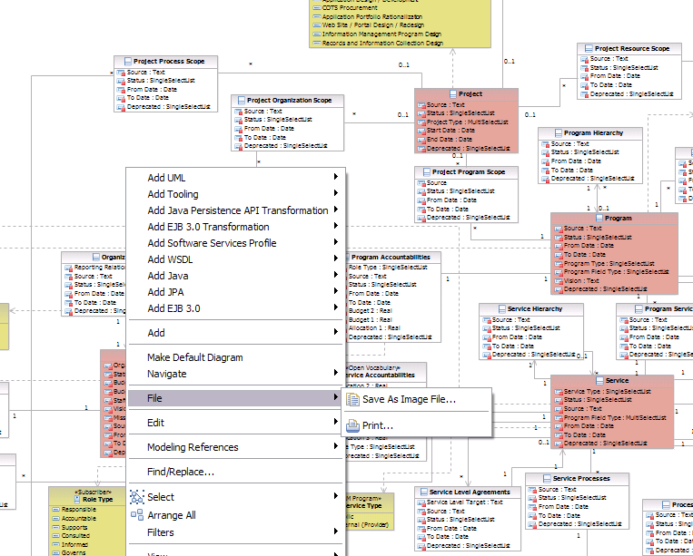
Figure 10. Saving a diagram as an image file

or export the entire model to html as shown in Figure 11 (Select Modeling->Publish->Web… from the toolbar in the RSM modeling perspective).

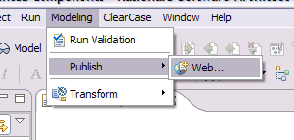
Figure 11. Publish model to html

Also, RSM supports BIRT, an open source reporting system that can be used to create reports from your UML model. See the tutorial “Generate a report for a UML model” (http://publib.boulder.ibm.com/infocenter/rsmhelp/v7r5m0/topic/com.ibm.xtools.publish.pdf.tutorial.doc/topics/pub_pdf_abstract.html)

Feature 34-36: Compare
Operation | Feature No. |  |  | Feature Description |  | SDW Tool
Compare |  | 34 | - Compare “My Municipality” meta model (extended meta model) to MRM meta model - run side by side comparson showing how model definitions differ and support graphical comparison of diagram changes |  | - RSM
 |  | 35 | - Compare multiple versions of [bc] or [r] instances within the same project |  | - ReqPro  - RRC
 |  | 36 | - Compare [bc] or [r] instances across multiple projects |  | - ReqPro Utility

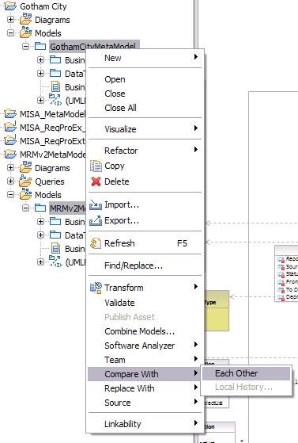
- Feature 34 – Within RSM, UML models (jurisdictional meta models) can be compared with one another (as long as they were created from same source, ie. Copy of one another). Once the MRMv2 meta mode is copied for a jurisdiction, as described in Feature 1, the jurisdiction model can be modified and then compared back to the original MRMv2 meta model. To do so in RSM, select the 2 or 3 (up to 3 models can be compared at once where one is the base- MRMv2 meta model) models and right click with the mouse. Select the option to Compare With->Each Other as shown in Figure 12.

Figure 12. Compare UML model in RSM

- Feature 35 – With RequisitePro, you can compare an entire project with a previous version using baselines. A baseline is a snapshot of a project at a particular point in time. To compare a project baseline with a previous project baseline launch the baseline manager in RequisitePro. The baseline manager is a tool used to create baselines and compare them. For more information on the baseline manager see “Using baselines in Rational RequisitePro” (http://publib.boulder.ibm.com/infocenter/reqpro/v7r1m0/topic/com.ibm.reqpro.help/administering/projects/baselines/c_using_baselines.html). Ignore UCM baselines. It is important to note that a baseline of one project cannot be compared to a baseline of a different project.
Within RRC, there is similar functionality to a baseline called Project Snapshots. For more information see “Project Snapshots” (http://publib.boulder.ibm.com/infocenter/rpcmpose/v2r0/topic/com.ibm.rational.rrc.help.doc/topics/c_snapshots.html)
- Feature 36 - A utility called ReqDiffTool is available that works with RequisitePro. This utility will compare any two RequisitePro projects. See the ReqDiffTool.

Feature 37: Link
Operation | Feature No. |  |  | Feature Description |  | SDW Tool
Link |  | 37 | - Link documents of [bc] instances |  | - RRC

Within RRC, any artifact can be linked to any other artifact. This is a way for Business Analysts to show dependencies and create relationships between artifacts. See “Creating Relationships between artifacts by using links” (http://publib.boulder.ibm.com/infocenter/rpcmpose/v2r0/topic/com.ibm.rational.rrc.help.doc/topics/t_work_links.html).

Feature 38: Customize Collaboration Site

Operation | Feature No. | Feature Description | SDW Tool
Customize Collaboration site | 38 | - Customize look and feel of collaboration site | - Quickr

Within Quickr, any place can be customized with additional pages, data and content. See “Setting up a place” (http://publib.boulder.ibm.com/infocenter/lqkrhelp/v8r0/topic/com.ibm.lotus.quickr.user.wp.doc/ts/setting_up_place.html)

Feature 39: Create
Operation | Feature No. |  |  | Feature Description |  | SDW Tool
Create |  | 39 | - Create new working space for project work |  | - RRC  - ReqPro  - RSM  - Quickr

Within each tool with the exception of Lotus Quickr, a project can be created. The project is a container where all data related to the MRMv2 data for a jurisdiction is contained. In Quickr, rather than a project a place is created (See Feature 38). Refer to the respective tool documentation for project creation.

Feature 40: Security

Operation | Feature No. |  |  | Feature Description |  | SDW Tool
Security |  | 40 | - Authorization rights (create, read, update, delete) can be setup to limit functionality by role |  | - RRC  - ReqPro  - Quickr

User authentication and security is available within RRC, Reqpro and Quickr. RSM does not have user security and relies on source & configuration management software (ie. CVS, Clearcase, Rational Team Concert) to manage user rights on artifact changes. LDAP is supported by RRC, Reqpro and Quickr. Refer to the respective tool documentation for details.

Note: when adding to the RSM model, there is a feature that synchronizes the model in RSM with ReqPro.

